End-to-End Retail Performance and Behavioural Analytics (RetailNova Inc.)
Name: Tanmay Kadwe
Tools:
Python | pandas | matplotlib | Ms SQL Server | Power BI | Jupyter Notebook
Date: 2026 Mar 05

Contents
- Executive Summary
- Business Objective
- Data Overview
- Methodology
4.1 Business Understanding
4.2 Data Understanding
4.3 Data Cleaning & Preprocessing
4.4 Feature Engineering
4.5 SQL-Based Analysis
4.6 Data Modelling
4.7 Visualization & Insights Generation
4.8 Documentation & Reporting
- Key Analysis & Insights
5.1 Sales Performance
5.2 Customer Insights
5.3 Product Performance
5.4 Store & Regional Performance
5.5 Return Analysis
- Dashboard Summary
- Business Recommendations
- Conclusion

- Executive Summary
This project analyses retail business performance using transaction, customer, product, store, and return data to identify patterns affecting revenue, profitability, and operational efficiency.
The analysis integrates Python for data cleaning and exploratory analysis, SQL Server for structured querying and data modelling, and Power BI for visualization and dashboard creation.
The study focuses on identifying:
- Revenue trends
- Customer behaviour patterns
- Product performance
- Store profitability
- Return patterns
The results highlight opportunities to improve profitability, reduce product returns, and enhance customer retention through data-driven decision making.

2. Business Objective
The objective of this analytics project is to enable data-driven decision making by analysing retail business data.
Key objectives include:
• Identifying revenue trends across time and sales channels
• Understanding customer demographics and purchasing behaviour
• Evaluating product and category performance
• Measuring store-level profitability
• Analyzing return patterns and their impact on profit
The insights generated support strategic decisions in marketing, operations, and product management.

3. Data Overview
The analysis used five datasets.
Sales Data
Contains transaction-level information including:
- order_id
- order_date
- customer_id
- product_id
- store_id
- quantity
- unit_price
- discount_pct
- total_amount
Customers Data
Includes customer demographic information:
- customer_id
- gender
- age
- signup_date
- region
Products Data
Contains product details:
- product_name
- category
- brand
- cost_price
- unit_price
- margin_pct
Stores Data
Includes store operational information:
- store_name
- city
- region
- operating_cost
Returns Data
Tracks returned orders:
- return_id
- order_id
- return_date
- return_reason

4. Methodology
The analysis followed a structured analytics workflow moving from raw data to business insights.

4.1 Business Understanding
The first step involved understanding the retail business challenges such as:
- high product returns
- declining profitability
- varying store performance
- changing customer behaviour
These challenges guided the analytical focus areas.

4.2 Data Understanding
All datasets were explored to understand:
- structure
- relationships between tables
- primary and foreign keys
- data quality issues
Exploratory analysis was conducted to detect:
- missing values
- duplicates
- inconsistent formats
- outliers

4.3 Data Cleaning & Preprocessing
Python was used to clean and prepare the datasets.
Cleaning steps included:
• Removing duplicate records
• Handling missing values
• Converting date columns to proper datetime format
• Standardizing column names
• Correcting data types
Cleaned datasets were exported for SQL analysis.

4.4 Feature Engineering
Additional columns were created to support analysis.
Examples include:
Revenue
Profit
Year-Month for trend analysis
Profit was calculated using:
Profit = Revenue − Cost
These derived variables helped create meaningful analytical insights.

4.5 SQL-Based Analysis
The cleaned datasets were loaded into Microsoft SQL Server.
SQL queries were written to answer business questions such as:
- total revenue trends
- top-selling products
- most profitable customers
- store-level profitability
- return rates
Techniques used included:
JOIN operations
GROUP BY aggregations
Window functions
Common Table Expressions (CTEs)

4.6 Data Modelling
A relational data model was created using Primary Keys and Foreign Keys.
Tables included:
Customers
Products
Stores
Salesdata
Orders
Returns
Salesdata acts as the fact table connected to dimension tables.
An ER Diagram was created to represent table relationships.
(Insert your ER Diagram screenshot here)

4.7 Visualization & Insight Generation
Power BI was used to create interactive dashboards.
Dashboards included:
Sales Overview
Customer Insights
Product Performance
Store Analysis
Return Analysis
Visual elements used:
KPI Cards
Bar Charts
Line Charts
Filters and slicers
These dashboards allow business users to explore data interactively.

4.8 Documentation & Reporting
The final stage involved documenting:
- methodology
- insights
- business recommendations
This ensures transparency and makes the analysis understandable to both technical and non-technical stakeholders.

5. Key Analysis & Insights

5.1 Sales Performance
Key observations:
• Monthly revenue trends show seasonal variation
• A small number of products contribute significantly to total sales
• Sales distribution varies between channels

5.2 Customer Insights
Customer analysis revealed:
• Customer distribution varies by region
• Certain age groups contribute higher revenue
• A small group of customers generates a large portion of total profit

5.3 Product Performance
Product-level insights include:
• Some categories generate high revenue but also high return rates
• High-margin products significantly impact profitability

5.4 Store & Regional Performance
Store performance analysis shows:
• Profitability varies significantly by store
• Some high-revenue stores have lower profit due to operating costs

5.5 Return Analysis
Return analysis indicates:
• Return rates differ by product category
• High-return products negatively impact profitability
Improving product quality and descriptions may reduce return rates.

6. Dashboard Summary
Power BI dashboards provide interactive analysis.
Key dashboards include:
- Sales Overview Dashboard
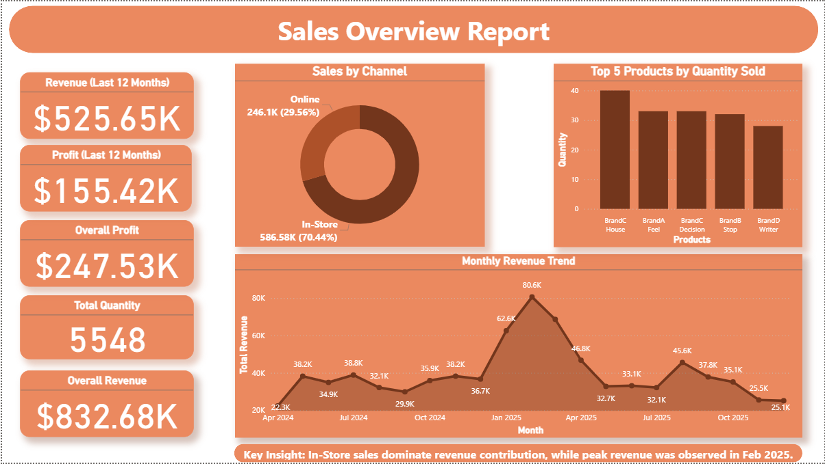

- Customer Insights Dashboard
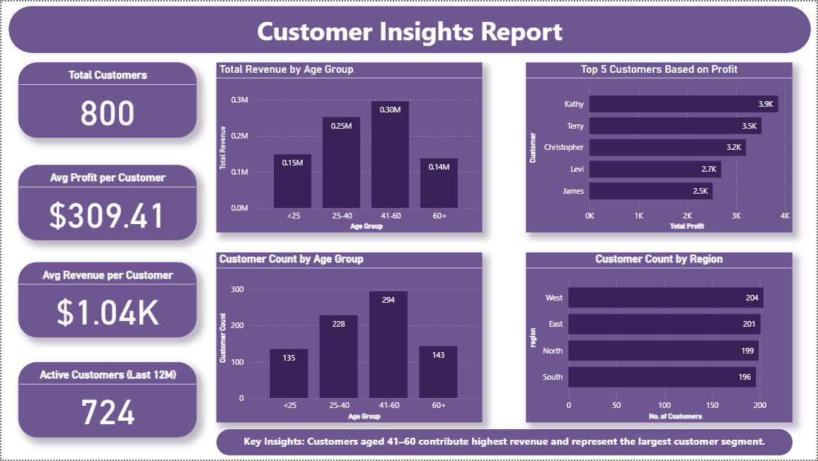

- Product Performance Dashboard
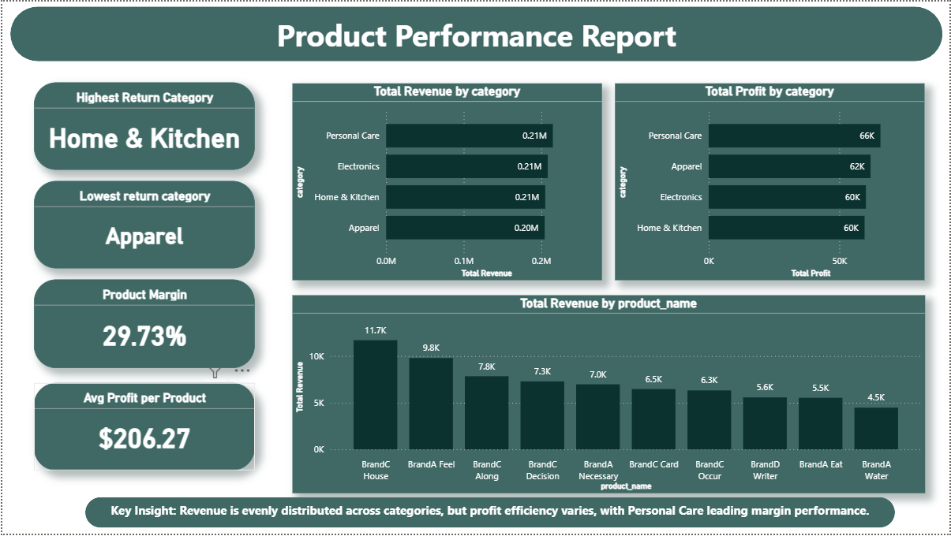

- Store Performance Dashboard
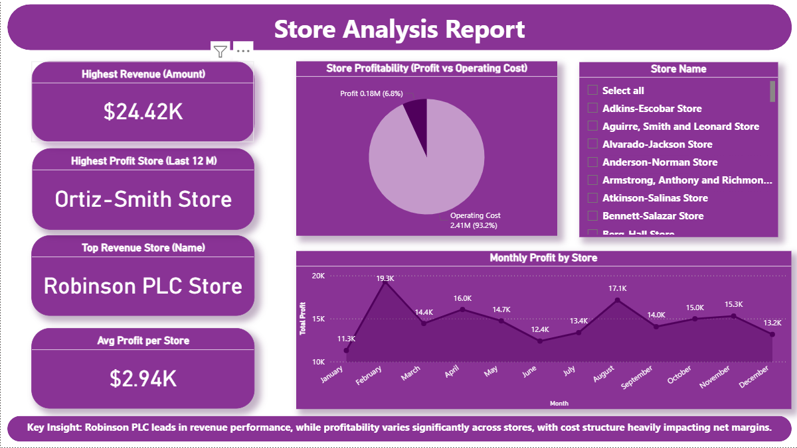

- Return Insights Dashboard
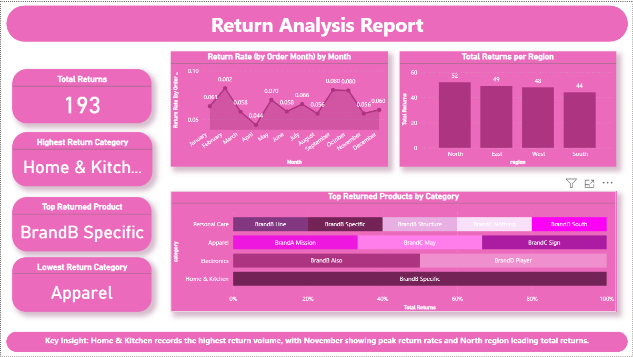

These dashboards allow stakeholders to quickly identify trends and make informed decisions.

7. Business Recommendations
Based on the analysis, the following actions are recommended:
- Improve product quality control to reduce returns
- Target marketing campaigns toward high-value customers
- Optimize operating costs in underperforming stores
- Promote high-margin products
- Improve product descriptions to reduce online returns

8. Conclusion
- This project demonstrates an end-to-end retail analytics workflow, combining data cleaning, SQL analysis, and Power BI visualization.
- The insights generated help businesses understand sales patterns, customer behaviour, and operational efficiency.
- By applying data-driven strategies, companies can improve profitability, customer satisfaction, and long-term growth.

